**Document for Taking the Backup of Jenkins Jobs and Upgrading Jenkins**

1)In order to take the backup of the existing Jenkins Jobs: Run the Batch file **backup_jobs_scripts.bat** which is available in the below mentioned lacation:

"E:\tools\ggScripts\a_backup_all\backup_jobs_scripts.bat"



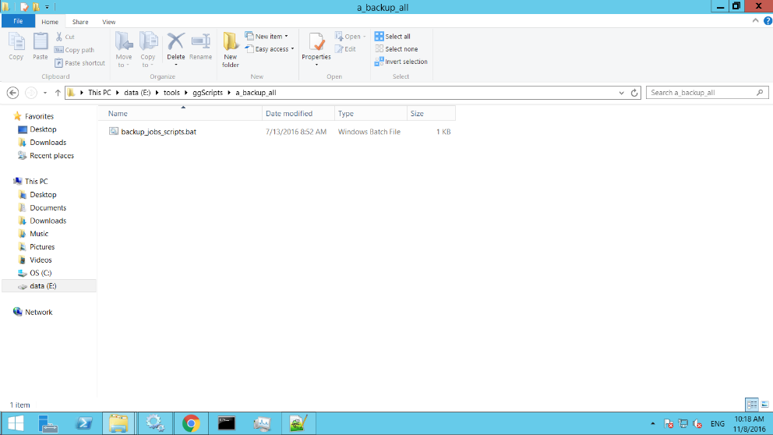

2) We can find the Backup zip file in **tools folder** as shown in the screenshot.

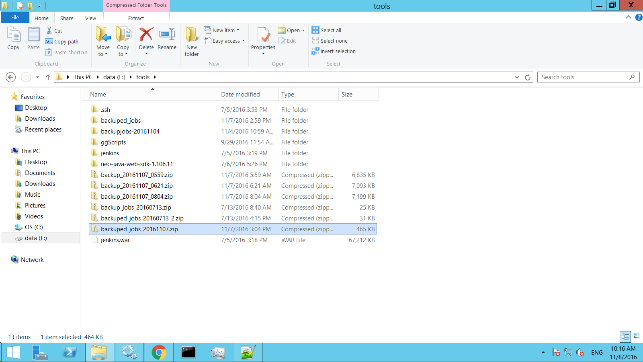

3) Stop the Tomcat server.

4) Download the new Jenkins war file

5) Now delete the existing **Jenkins folder and Jenkins.war file** from Tomcat -> Webapps Folder as shown in the screenshot.

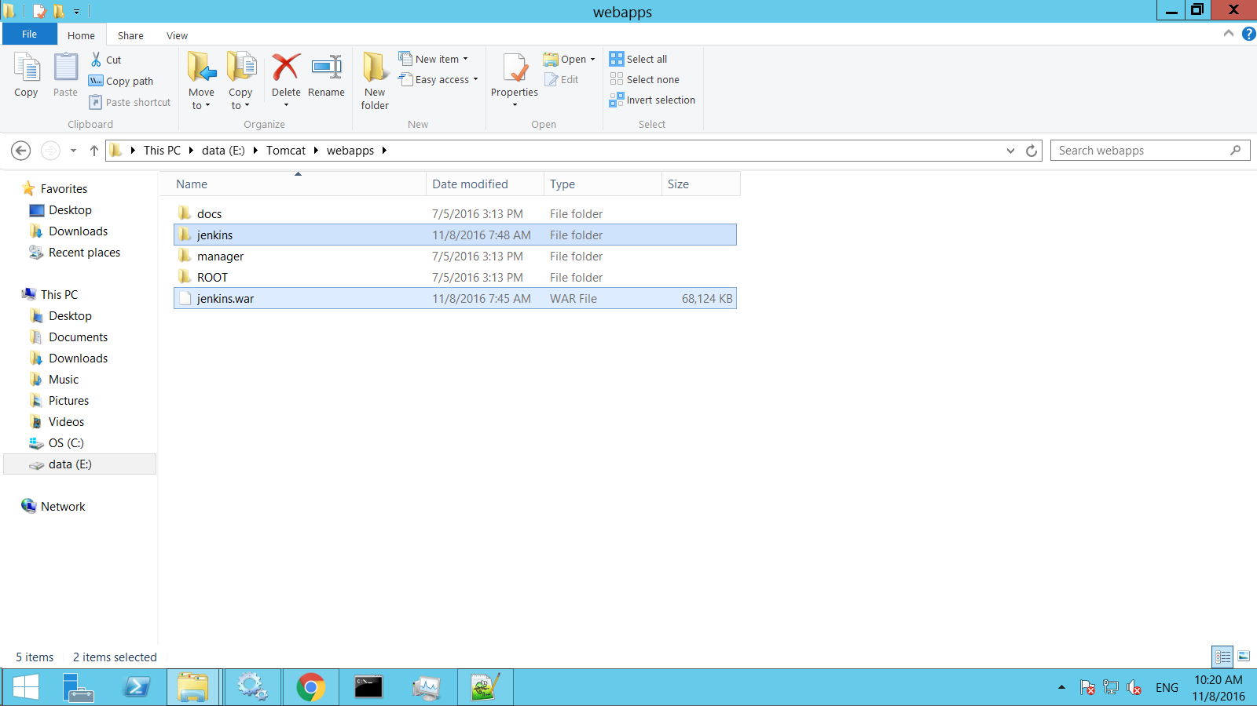

6) Copy and paste the newly downloaded Jenkins.war file in Tomcat -> webapp Folder

7) Now start the Tomcat server by clicking on Start button as shown in the screenshot.

